Index Number: 210620M

Name: S.M.K.G.L.S. Subasinghe

**CS2023 - Inclass Lab**

**Week 9 - Hash tables**

Lab09 Repository link:

Repository link for all labs:

**Section 1**

2. Insert your name as user name and your index number as password. Print hash table and take screenshot.

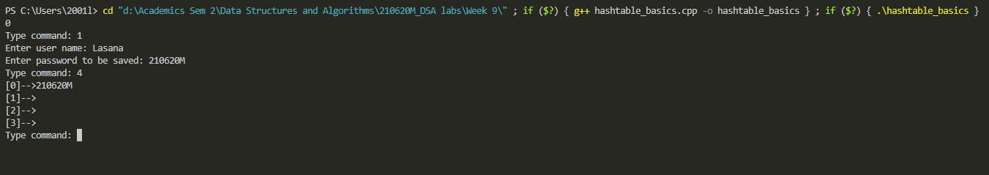

3. Add 3 more user names and passwords. Print hash table and take screenshot.

4. Delete your user name. Print hash table and take screenshot.

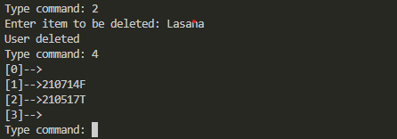

5. What is issue when using a simple hash table like this and how can we change it, explain your answer.

In this type of basic Hash table more than one entry with the same hash value cannot be stored. We can resolve this by assigning linked lists for the consecutive hash indexes where more than one values with the same hash value can be saved.

Open addressing is also another method.

**Section 2**

2. Insert your name as user name and your index number as password(do it two times). Print hash table and take screenshot.

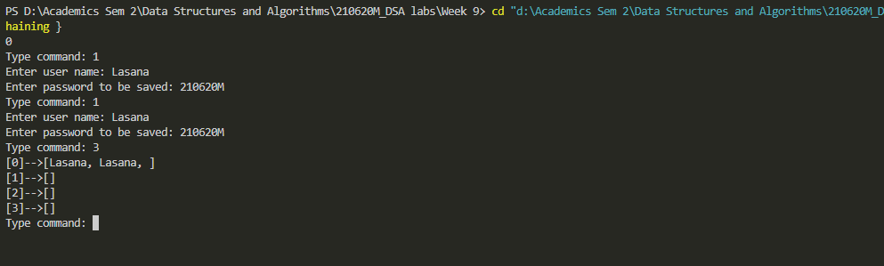

3. Add 3 more user names and passwords. Print hash table and take screenshot.

